**Git Commands:**

## **1. Initialize a local repository**

## **2. Add a file to the staging area**

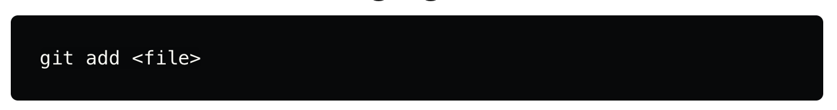

To add all files in the current directory, use . in place of <file>.

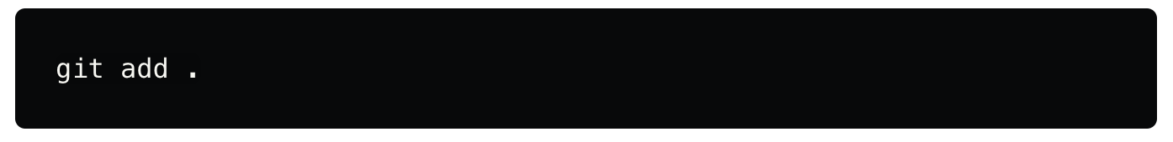

## **3. Check the status of the repository**

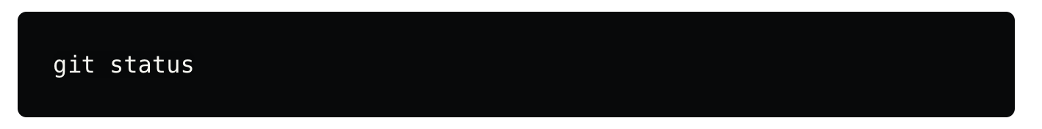

## **4. Commit changes**

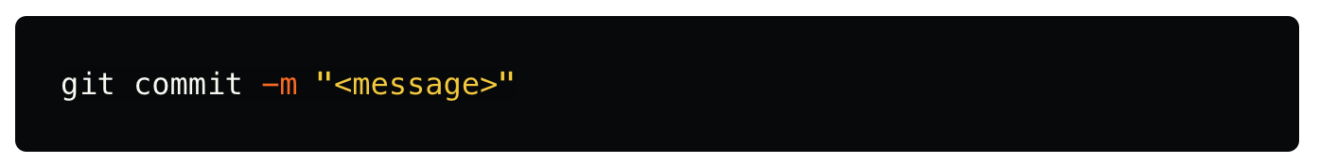

## **5. Add a remote repository**



## **6. Push changes to a remote repository branch**

## 

## **7. Clone a remote repository**



## **8. Pull changes from a remote repository**

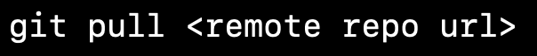

## **9. Remove a file from the staging area**

## 

## **10. Remove a file from the repository**

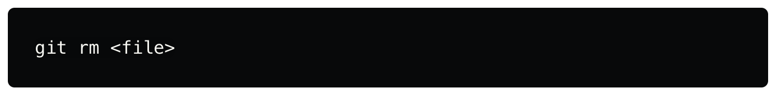

Note: After doing git rm <file>, we also have to do git commit -m "message"

## **11. Create a branch**

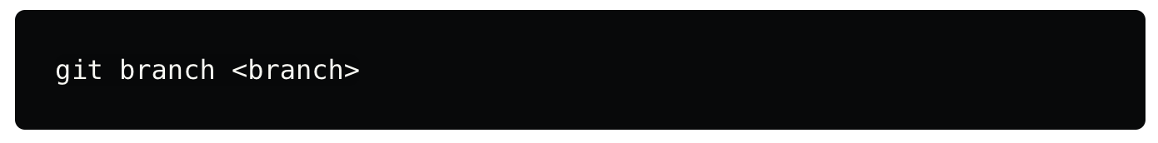

You can **create** a **branch** and **switch** to it using the checkout command.

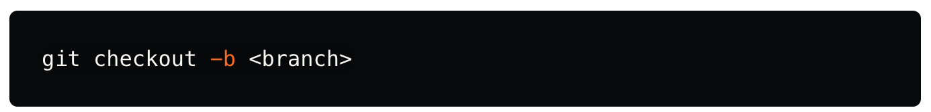

## **12. Switch to a branch**

## **13. Delete a branch**

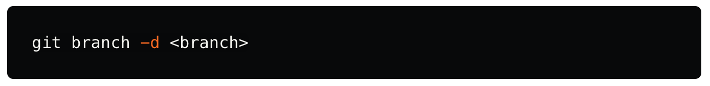

## **14. List branches**

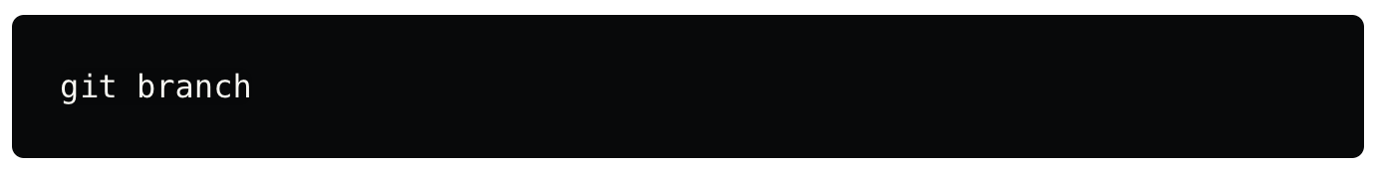

## **15. Display the commit history**

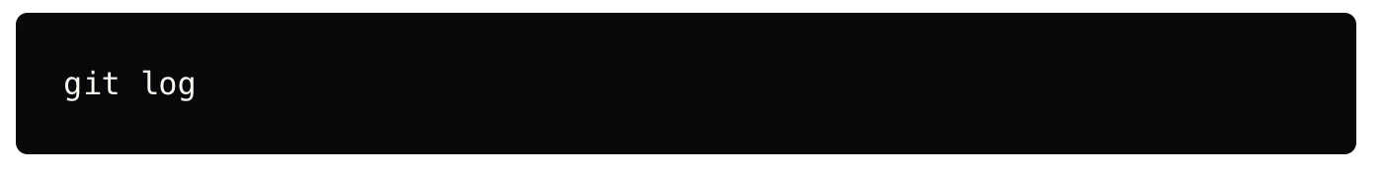

## **16. Display the commit history in online**

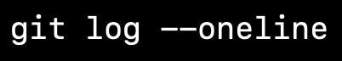

## **17. Stash changes :** The stash allows you to temporarily store changes without committing them.

## To stash your staged files without committing them

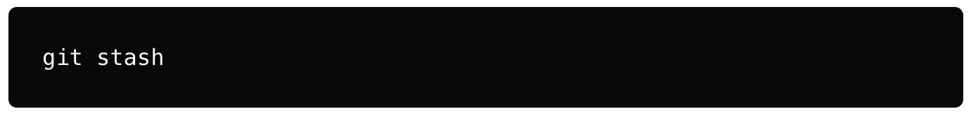

To stash your staged files along with untracked files then



## **18. List stashes**

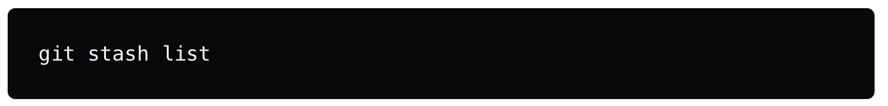

## **19. Restore changes from stash and remove it**

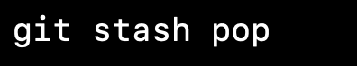

## **20. Revert a commit**

This command helps you to reverting a commit to previous version

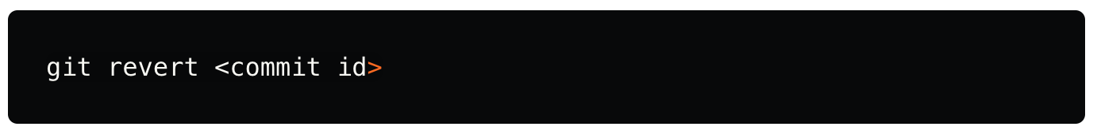

## **21. Display the changes between two commits**

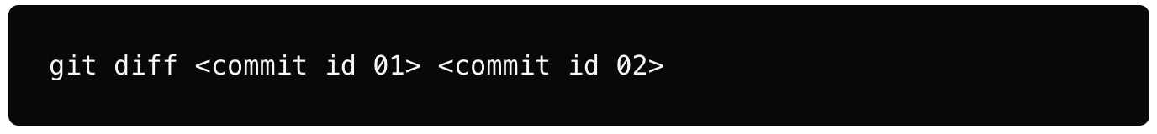

## **22. Merge a branch**



## 

## **23. rebase a branch**



## **24. hard Reset**



## **25. soft Reset**

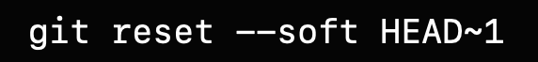

## **26. mixed Reset**

